JAVA AWT BASED- REGISTRATION FORM- SQL CONNECTIVITY USING JDBC
A
Report
Submitted in partial fulfilment of the
Requirements for the award of the Degree of
BACHELOR OF ENGINEERING
IN
INFORMATION TECHNOLOGY
By
K.GRETA <1602-18-737-069>

Department of Information Technology
Vasavi College of Engineering (Autonomous)
(Affiliated to Osmania University)
Ibrahimbagh, Hyderabad-31,2019
BONAFIDE CERTIFICATE
This to Certify that the project report titled “FEEDBACK RETRIEVAL SYSTEM OF HOTELS” project work of Ms K.GRETA bearing Roll.no:1602-18-737-069 who carried out this project under my supervision in the IV semester for the academic year 2019-2020

Signature Signature
external examine internal examine

AIM:
To create a Java GUI based Feedback form for Hotels which takes the details of all the hotels, feedbacks and persons who are giving feedback from the user. These values are to be updated in the database using JDBC connectivity .

ABSTRACT:
Feedback Retrieval System for Hotels
Feedback retrieval system for hotels basically helps all the hotels to collect feedback from people. The user enters his details first and checks the information of the hotel and gives the feedback in form of suggestions and rating. The user will also post the complaints which will be further improved by the management of the hotels. Users can also view the feedbacks given for other hotels and choose the hotels.

INTRODUCTION:
REQUIREMENT SPECIFICATION:
This database consists of 4 Entites namely Persons,Hotels,Services,Feedback and 3 relationships i.e.,
Person: Entity set contains the information of the person who gives feedback.
Attributes:
- Pid NUMBER(primary).
- Name VARCHAR
- Contact NUMBER(10)
- Mail VARCHAR2(20).
Hotels: It is an entity set which contains the information of all the hotels.
Attributes:
- Name VARCHAR2(10)
- Hid NUMBER(2) (primary)
- Contact NUMBER(10)
- Address VARCHAR2(30).
Services: It is an entity which provides the information of services provided by the Hotel.
- Hid NUMBER(2)
- Sid NUMBER(5),
- Rooms VARCHAR2(100),
- Food VARCHAR2(100)
- Gamezone VARCHAR2(100),
- Ambience VARCHAR2(100).
Feedback: It helps in collecting the feedback from persons.
Attributes:
- Fid NUMBER(3) (primary)
- Complaints VARCHAR2(100)
- Suggestions VARCHAR2(100)
- Rating VARCHAR2(100)

Cardinalities:
1.Checks:Person checks the information of hotels.
2.Provides:Services provided by the hotel.
3.Gives:Feedback given by the user for a particular hotel.
The cardinalities are Person(Many)-hotels(Many),Person(one)-feedback(many). This helps the organisation to improvise their hotels. ER
SOFTWARE USED:
Java Eclipse, Oracle 11g Database, Java SE version 7, SQL*Plus.

Java AWT (Abstract Window Toolkit) is an API to develop GUI or window-based applications in java.
Java AWT components are platform-dependent i.e. components are displayed according to the view of operating system. AWT is heavyweight i.e. its components are using the resources of OS.
The java.awt package provides classes for AWT API such as TextField, Label, TextArea, RadioButton, CheckBox, Choice, List etc.

JAVA SWING:
Swing is a GUI widget toolkit for Java. It is part of Oracle 's Java Foundation Classes (JFC) – an API for providing a graphical user interface (GUI) for Java programs. Swing was developed to provide a more sophisticated set of GUI components than the earlier Abstract Window Toolkit (AWT).
SQL:
Structure Query Language(SQL) is a database query language used for storing and managing data in Relational DBMS. SQL was the first commercial language introduced for E.F Codd's Relational model of database. Today almost all RDBMS (MySql, Oracle, Infomix, Sybase, MS Access) use SQL as the standard database query language. SQL is used to perform all types of data operations in RDBMS.

Java-SQL Connectivity using JDBC:
Java Database Connectivity (JDBC) is an application programming interface (API) for the programming language Java, which defines how a client may access a database. It is a Java-based data access technology used for Java database connectivity. It is part of the Java Standard Edition platform, from Oracle Corporation. It provides methods to query and update data in a database and is oriented towards relational databases.
The connection to the database can be performed using Java programming (JDBC API) as:
private void connToDb(){
try {
Class.forName("oracle.jdbc.driver.OracleDriver");
connection = DriverManager.getConnection("jdbc:oracle:thin:@localhost:1522:xe","greta","GRETA0910");
statement = connection.createStatement();

} catch (SQLException connectException) {
System.out.println(connectException.getMessage());
System.out.println(connectException.getSQLState());
System.out.println(connectException.getErrorCode());
System.exit(1);
}
catch (Exception e)
{
System.err.println("Unable to find and load driver");
System.exit(1);
}
}
Thus, the connection from Java to Oracle database is performed and therefore, can be used for updating tables in the database directly.

DESIGN:
1.ER DIAGRAM:
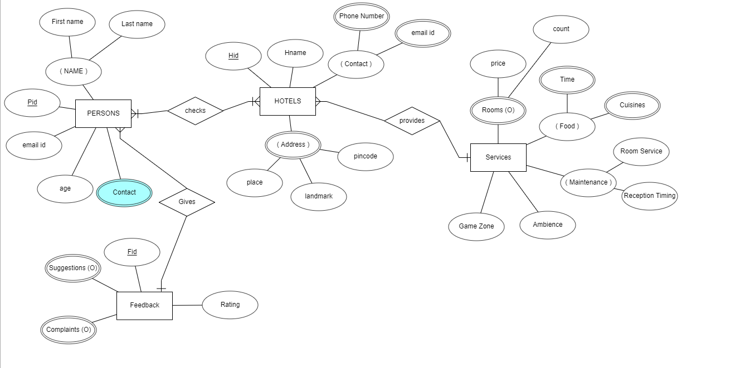

Tables Created in SQL for above mentioned purpose is as:
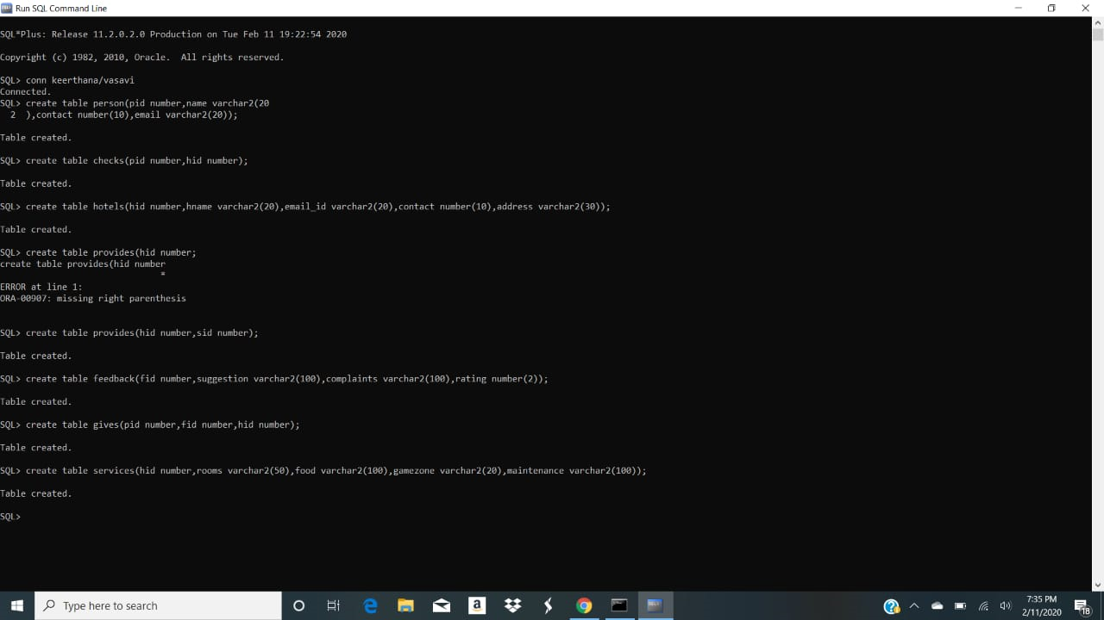

Program:

IMPLEMENTATION:
import java.awt.EventQueue;
import java.awt.TextArea;
import javax.swing.JFrame;
import java.awt.CardLayout;
import java.awt.Color;
import java.awt.BorderLayout;
import javax.swing.SpringLayout;
import javax.swing.JLabel;
import javax.swing.JOptionPane;
import javax.swing.JTextField;
import javax.swing.JFormattedTextField;
import javax.swing.JToggleButton;
import javax.swing.JComboBox;
import java.awt.event.ActionListener;
import java.sql.Connection;
import java.sql.DriverManager;
import java.sql.ResultSet;
import java.sql.SQLException;
import java.sql.Statement;
import java.awt.event.ActionEvent;
import java.awt.List;
import java.awt.event.ItemListener;
import java.awt.event.ItemEvent;

public class PGUI1 {
TextArea ftf = new TextArea();
Connection connection;
Statement statement;
private JFrame frame;
private JTextField tfname;
private JTextField tfid;
private JTextField tfage;
private JTextField tfcont;
private JTextField tfemail;
List list = new List(10);
ResultSet rs;
public PGUI1()
{ try
{
Class.forName("oracle.jdbc.driver.OracleDriver");
}
catch (Exception e)
{
System.err.println("Unable to find and load driver");
System.exit(1);
}
connection();
initialize();
}
private void connection()
try
{
connection = DriverManager.getConnection("jdbc:oracle:thin:@localhost:1521:xe","greta","GRETA0910");
statement = connection.createStatement();
}
catch (SQLException connectException)
{
System.out.println(connectException.getMessage());
System.out.println(connectException.getSQLState());
System.out.println(connectException.getErrorCode());
System.exit(1);
}
}
public static void main(String[] args) {
EventQueue.invokeLater(new Runnable() {
public void run() {
try {
PGUI1 window = new PGUI1();
window.getFrame().setVisible(true);
} catch (Exception e) {
e.printStackTrace();
}}});}
private void loadList()
{
try
{
rs = statement.executeQuery("SELECT PID FROM PERSONS");
while (rs.next())
{
list.add(rs.getString("PID"));
}
}
catch (SQLException e)
{
ftf.append(e.getMessage());
}}
private void initialize() {
setFrame(new JFrame());
getFrame().getContentPane().setBackground(Color.PINK);
SpringLayout springLayout = new SpringLayout();
getFrame().getContentPane().setLayout(springLayout);

JLabel lblNewLabel = new JLabel("Person Name:");
getFrame().getContentPane().add(lblNewLabel);

JLabel lblNewLabel_1 = new JLabel("Person Id:");
getFrame().getContentPane().add(lblNewLabel_1);

JLabel lblNewLabel_2 = new JLabel("Age:");
getFrame().getContentPane().add(lblNewLabel_2);
JLabel lblNewLabel_3 = new JLabel("Contact:");
getFrame().getContentPane().add(lblNewLabel_3);
JLabel lblEmailId = new JLabel("Email Id:");
getFrame().getContentPane().add(lblEmailId);

tfname = new JTextField();
getFrame().getContentPane().add(tfname);
tfname.setColumns(10);

tfid = new JTextField();
getFrame().getContentPane().add(tfid);
tfid.setColumns(10);
tfage = new JTextField();
getFrame().getContentPane().add(tfage);
tfage.setColumns(10);

tfcont = new JTextField();
tfcont.setColumns(10);
tfemail = new JTextField();
getFrame().getContentPane().add(tfemail);
tfemail.setColumns(10);
JToggleButton tglbtnUpdateSailor = new JToggleButton("update");
tglbtnUpdateSailor.addActionListener(new ActionListener() {
public void actionPerformed(ActionEvent e) {
try
{
Statement statement = connection.createStatement();
int i = statement.executeUpdate("UPDATE PERSONS "
+ "SET NAME ='" + tfname.getText() + "', "
+ "AGE = " + tfage.getText() + ","
+ "CONTACT = '" + tfcont.getText()
+ "',"+"EMAIL_ID='"+tfemail.getText()
+ " 'WHERE PID= "
+ list.getSelectedItem());
ftf.append("\nUpdated " + i + " rows successfully");
list.removeAll();
loadList();
}
catch (SQLException insertException)
{
ftf.append(insertException.getMessage());
}}});
getFrame().getContentPane().add(tglbtnUpdateSailor);
JToggleButton tglbtnBack = new JToggleButton("back");
tglbtnBack.addActionListener(new ActionListener() {
public void actionPerformed(ActionEvent e) {
try {
DEMO window = new DEMO();
(window).getframe().setVisible(true);
} catch (Exception es) {
es.printStackTrace();
}}});
frame.getContentPane().add(tglbtnBack);
loadList();
list.addItemListener(new ItemListener() {
public void itemStateChanged(ItemEvent arg0) {
try
{
rs = statement.executeQuery("SELECT * FROM PERSONS where PID ="+list.getSelectedItem());
rs.next();
tfid.setText(rs.getString("PID"));
tfname.setText(rs.getString("NAME"));
tfage.setText(rs.getString("AGE"));
tfcont.setText(rs.getString("CONTACT"));
tfemail.setText(rs.getString("email_id"));

}
catch (SQLException selectException)
{
ftf.append(selectException.getMessage());
}}});
frame.getContentPane().add(list);
getFrame().setBounds(100, 100, 450, 300);
getFrame().setDefaultCloseOperation(JFrame.EXIT_ON_CLOSE);
}
public JFrame getFrame() {
return frame;
}
public void setFrame(JFrame frame) {
this.frame = frame;
}
}
2.Insert
import java.awt.EventQueue;
import java.awt.TextArea;
import javax.swing.JFrame;
import java.awt.CardLayout;
import java.awt.Color;
import javax.swing.SpringLayout;
import javax.swing.JLabel;
import javax.swing.JTextField;
import javax.swing.JFormattedTextField;
import javax.swing.JToggleButton;
import java.awt.event.ActionListener;
import java.sql.Connection;
import java.sql.DriverManager;
import java.sql.SQLException;
import java.sql.Statement;
import java.awt.event.ActionEvent;

public class PGUI2 {
TextArea ftf = new TextArea();
Connection connection;
Statement statement;
private JFrame frame;
private JTextField tfname;
private JTextField tfid;
private JTextField tfage;
private JTextField tfcont;
private JTextField tfemail;
public PGUI2()
{try
{
Class.forName("oracle.jdbc.driver.OracleDriver");
}
catch (Exception e)
{
System.err.println("Unable to find and load driver");
System.exit(1);
}
connection();
initialize();
}
private void connection() {
try
{
connection = DriverManager.getConnection("jdbc:oracle:thin:@localhost:1521:xe","greta","GRETA0910");
statement = connection.createStatement();
}
catch (SQLException connectException)
{
System.out.println(connectException.getMessage());
System.out.println(connectException.getSQLState());
System.out.println(connectException.getErrorCode());
System.exit(1);
}
}
public static void main(String[] args) {
EventQueue.invokeLater(new Runnable() {
public void run() {
try {
PGUI2 window = new PGUI2();
window.getFrame().setVisible(true);
} catch (Exception e) {
e.printStackTrace();
}}});}
private void initialize() {
setFrame(new JFrame());
getFrame().getContentPane().setBackground(Color.PINK);
SpringLayout springLayout = new SpringLayout();
getFrame().getContentPane().setLayout(springLayout);

JLabel lblNewLabel = new JLabel("Person Name:");
getFrame().getContentPane().add(lblNewLabel);
JLabel lblNewLabel_1 = new JLabel("Person Id:");
getFrame().getContentPane().add(lblNewLabel_1);
JLabel lblNewLabel_2 = new JLabel("Age:")
getFrame().getContentPane().add(lblNewLabel_2);
JLabel lblNewLabel_3 = new JLabel("Contact:");
getFrame().getContentPane().add(lblNewLabel_3);
JLabel lblEmailId = new JLabel("Email Id:");
getFrame().getContentPane().add(lblEmailId);
tfname = new JTextField();
getFrame().getContentPane().add(tfname);
tfname.setColumns(10);
tfid = new JTextField();
getFrame().getContentPane().add(tfid);
tfid.setColumns(10);
tfage = new JTextField();
getFrame().getContentPane().add(tfage);
tfage.setColumns(10);

tfcont = new JTextField();
getFrame().getContentPane().add(tfcont);
tfcont.setColumns(10);
tfemail = new JTextField();
getFrame().getContentPane().add(tfemail);
tfemail.setColumns(10);
getFrame().getContentPane().add(ftf);
JToggleButton tglbtnUpdateSailor = new JToggleButton("Insert Person");
tglbtnUpdateSailor.addActionListener(new ActionListener() {
public void actionPerformed(ActionEvent e) {
try
{
Statement statement = connection.createStatement();
String query= "INSERT INTO PERSONS VALUES(" + tfid.getText() + ", " + "'" + tfname.getText() + "'," +tfage.getText() + "," + "'" + tfcont.getText() + "',"+"'"+tfemail.getText()+"'"+")";
int i = statement.executeUpdate(query);
ftf.append("\nInserted " + i + " rows successfully");
}
catch (SQLException insertException)
{
ftf.append(insertException.getMessage());}}});
getFrame().getContentPane().add(tglbtnUpdateSailor);
JToggleButton tglbtnBack = new JToggleButton("back");
tglbtnBack.addActionListener(new ActionListener() {
public void actionPerformed(ActionEvent e) {
try {
DEMO window = new DEMO();
(window).getframe().setVisible(true);
} catch (Exception es) {
es.printStackTrace();
}}});
frame.getContentPane().add(tglbtnBack);
getFrame().setBounds(100, 100, 450, 300);
getFrame().setDefaultCloseOperation(JFrame.EXIT_ON_CLOSE);
}

public JFrame getFrame() {
return frame;
}

public void setFrame(JFrame frame) {
this.frame = frame;
}}
3.DELETE
import java.awt.EventQueue;
import java.awt.TextArea;
import javax.swing.JFrame;
import java.awt.CardLayout;
import java.awt.Color;
import java.awt.BorderLayout;
import javax.swing.SpringLayout;
import javax.swing.JLabel;
import javax.swing.JOptionPane;
import javax.swing.JTextField;
import javax.swing.JFormattedTextField;
import javax.swing.JToggleButton;
import java.awt.event.ActionListener;
import java.sql.Connection;
import java.sql.DriverManager;
import java.sql.ResultSet;
import java.sql.SQLException;
import java.sql.Statement;
import java.awt.event.ActionEvent;
import java.awt.List;
import java.awt.event.ItemListener;
import java.awt.event.ItemEvent;

public class PGUI3 {
TextArea ftf = new TextArea();
Connection connection;
Statement statement;
private JFrame frame;
private JTextField tfname;
private JTextField tfid;
private JTextField tfage;
private JTextField tfcont;
private JTextField tfemail;
List list = new List(10);
ResultSet rs;
public PGUI3()
{ try
{
Class.forName("oracle.jdbc.driver.OracleDriver");
}
catch (Exception e)
{
System.err.println("Unable to find and load driver");
System.exit(1);
}
connectToDB();
initialize();
}

private void connectToDB() {
try
{
connection = DriverManager.getConnection("jdbc:oracle:thin:@localhost:1521:xe","greta","GRETA0910");
statement = connection.createStatement();

}
catch (SQLException connectException)
{
System.out.println(connectException.getMessage());
System.out.println(connectException.getSQLState());
System.out.println(connectException.getErrorCode());
System.exit(1);
}
}
public static void main(String[] args) {
EventQueue.invokeLater(new Runnable() {
public void run() {
try {
PGUI3 window = new PGUI3();
window.getFrame().setVisible(true);
} catch (Exception e) {
e.printStackTrace();
}}});}
private void loadList()
{ try
{
rs = statement.executeQuery("SELECT PID FROM PERSONS");
while (rs.next())
{
list.add(rs.getString("PID"));
}
}
catch (SQLException e)
{
ftf.append(e.getMessage());
}}
private void initialize() {
setFrame(new JFrame());
getFrame().getContentPane().setBackground(Color.PINK);
SpringLayout springLayout = new SpringLayout();
getFrame().getContentPane().setLayout(springLayout);

JLabel lblNewLabel = new JLabel("Person Name:");
getFrame().getContentPane().add(lblNewLabel);

JLabel lblNewLabel_1 = new JLabel("Person Id:");
getFrame().getContentPane().add(lblNewLabel_1);
JLabel lblNewLabel_2 = new JLabel("Age:");
getFrame().getContentPane().add(lblNewLabel_2);
JLabel lblNewLabel_3 = new JLabel("Contact:");
getFrame().getContentPane().add(lblNewLabel_3);
JLabel lblEmailId = new JLabel("Email Id:");

getFrame().getContentPane().add(lblEmailId);
tfname = new JTextField();
getFrame().getContentPane().add(tfname);
tfname.setColumns(10);
tfid = new JTextField();
getFrame().getContentPane().add(tfid);
tfid.setColumns(10);
tfage = new JTextField();
getFrame().getContentPane().add(tfage);
tfage.setColumns(10);
tfcont = new JTextField();
getFrame().getContentPane().add(tfcont);
tfcont.setColumns(10);
tfemail = new JTextField();
getFrame().getContentPane().add(tfemail);
tfemail.setColumns(10);
getFrame().getContentPane().add(ftf);
JToggleButton tglbtnDeletePerson = new JToggleButton("delete");
tglbtnDeletePerson.addActionListener(new ActionListener() {
public void actionPerformed(ActionEvent e) {
try
{
Statement statement = connection.createStatement();
int i = statement.executeUpdate("DELETE FROM PERSONS WHERE PID = "
+ list.getSelectedItem());
ftf.append("\nDeleted " + i + " rows successfully");
tfid.setText(null);
tfname.setText(null);
tfcont.setText(null);
tfage.setText(null);
tfcont.setText(null);
tfemail.setText(null);
list.removeAll();
loadList();
}
catch (SQLException insertException)
{
ftf.append(insertException.getMessage());
}

}
}
);
getFrame().getContentPane().add(tglbtnDeletePerson);
JToggleButton tglbtnBack = new JToggleButton("back");
tglbtnBack.addActionListener(new ActionListener() {
public void actionPerformed(ActionEvent e) {
try {
DEMO window = new DEMO();
(window).getframe().setVisible(true);
} catch (Exception es) {
es.printStackTrace();
}}});
frame.getContentPane().add(tglbtnBack);
loadList();
list.addItemListener(new ItemListener() {
public void itemStateChanged(ItemEvent arg0) {
try
{
rs = statement.executeQuery("SELECT * FROM PERSONS where PID ="+list.getSelectedItem());
rs.next();
tfid.setText(rs.getString("PID"));
tfname.setText(rs.getString("NAME"));
tfage.setText(rs.getString("AGE"));
tfcont.setText(rs.getString("CONTACT"));
tfemail.setText(rs.getString("email_id"));

}
catch (SQLException selectException)
{
ftf.append(selectException.getMessage());
}}});
frame.getContentPane().add(list);
getFrame().setBounds(100, 100, 450, 300);
getFrame().setDefaultCloseOperation(JFrame.EXIT_ON_CLOSE);
}
public JFrame getFrame() {
return frame;
}

public void setFrame(JFrame frame) {
this.frame = frame;
}
}

OUTPUT SCREENSHOTS:
Java GUI Screenshot:
GUI MAIN:
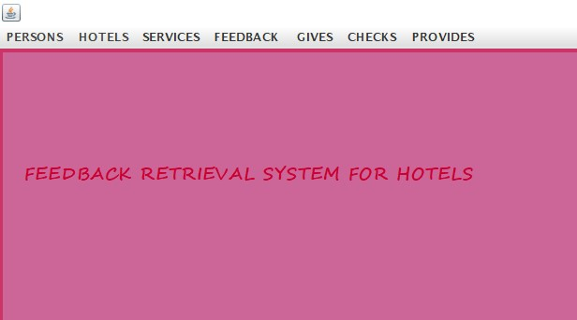

GUI OF TABLE : PERSONS
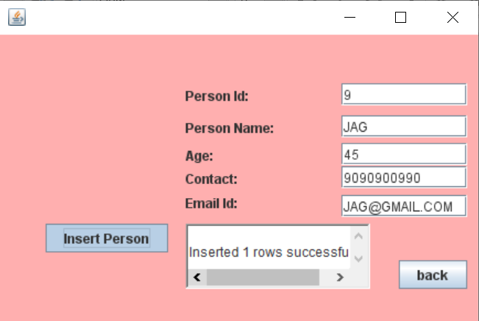

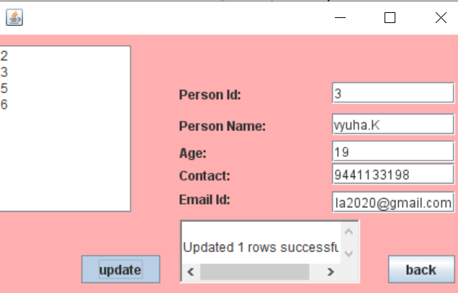

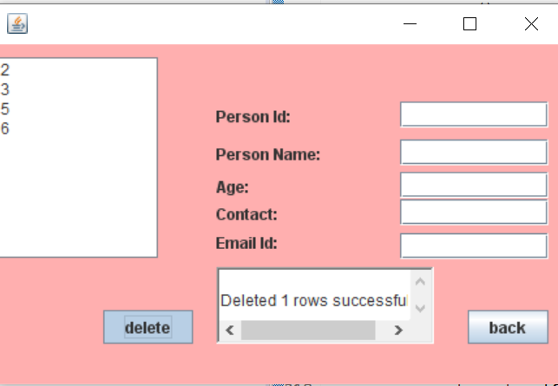

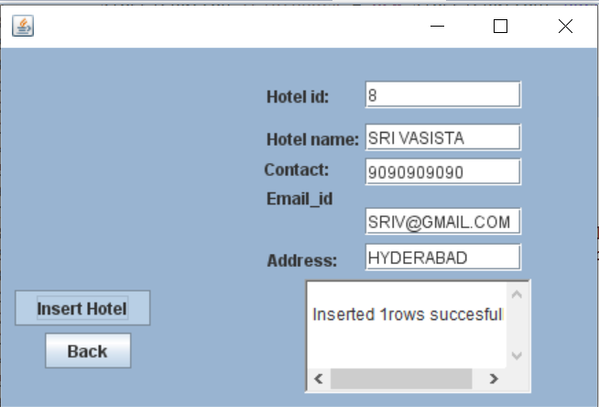
GUI OF TABLE HOTELS:

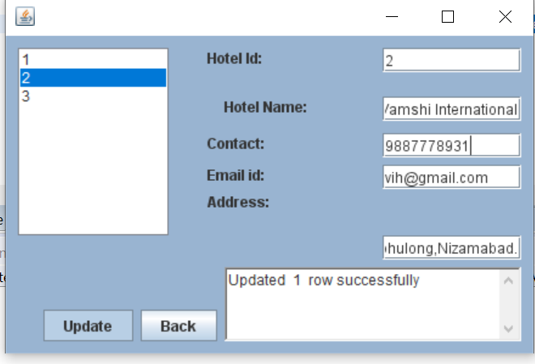

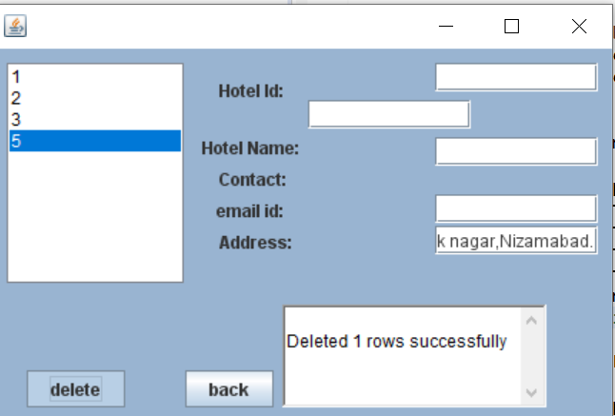

GUI OF RELATION CHECKS:
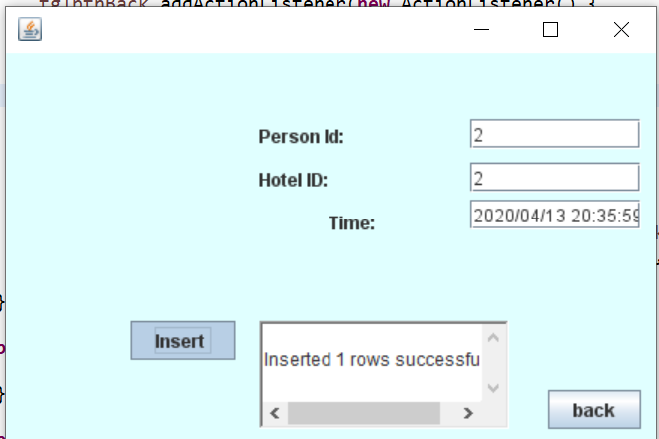

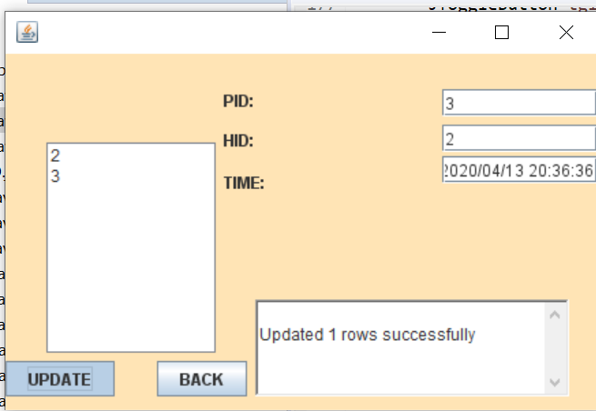

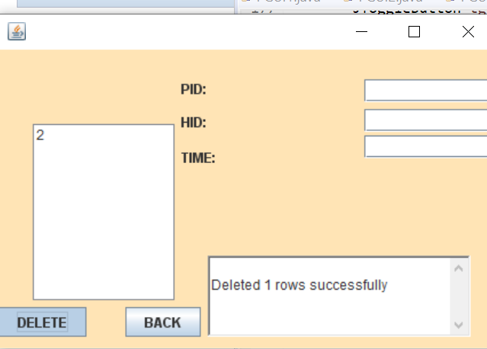

GUI OF RELATION PROVIDES:
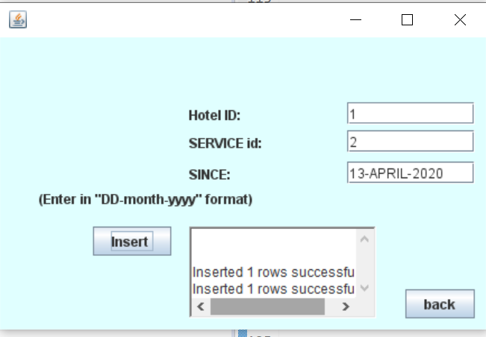

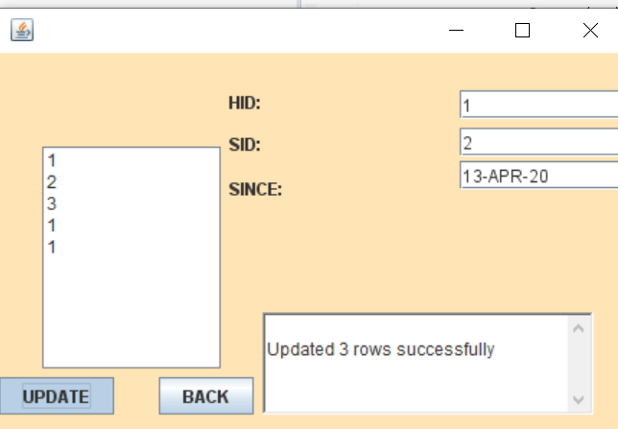

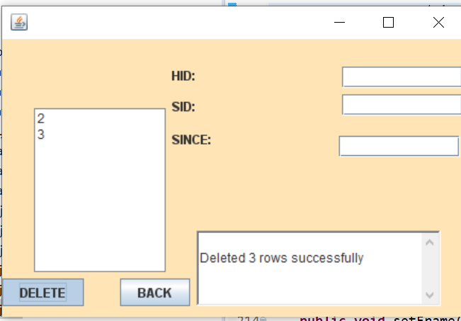

GUI OF TABLE SERVICES:
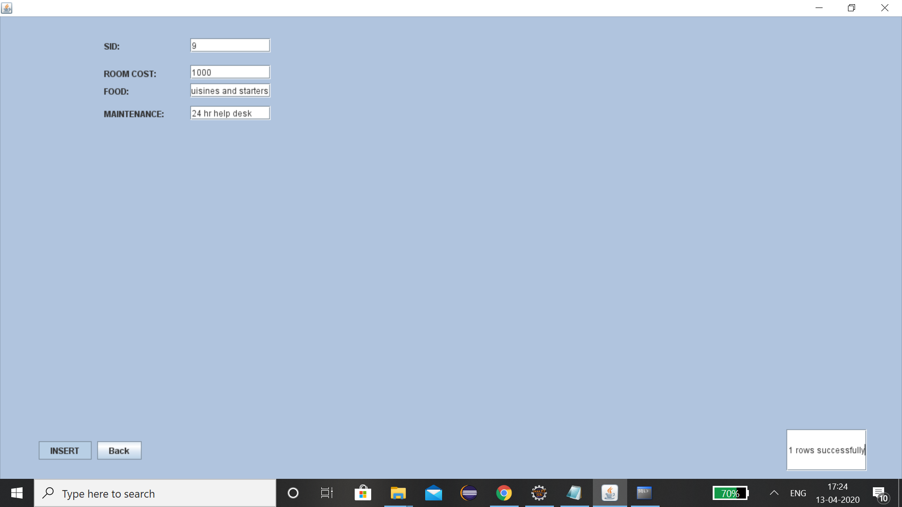

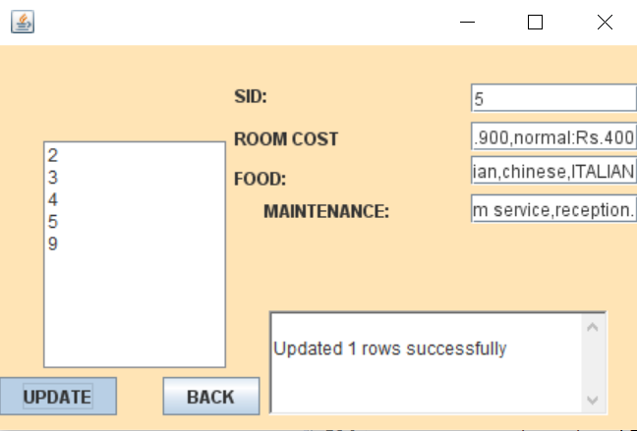

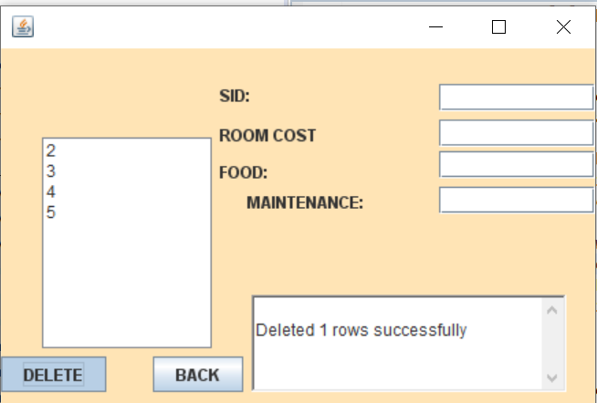

GUI OF TABLE GIVES:
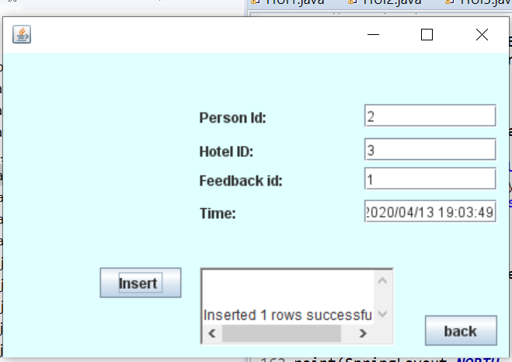

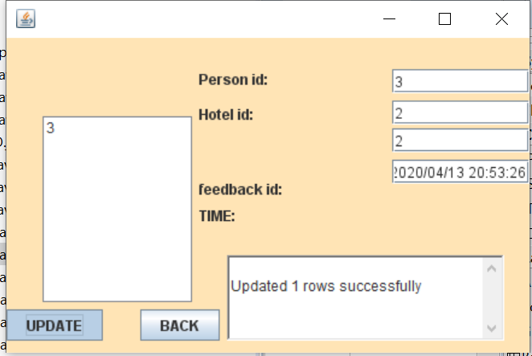

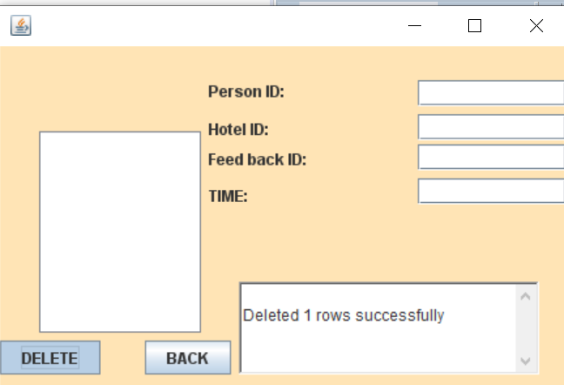

Testing:
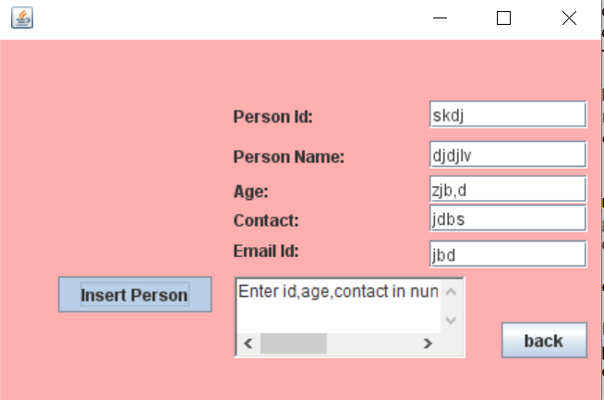

CONCLUSION: Thus, this Java AWT feedback retrieval system created which is connected to the Oracle 11g database. Therefore, all the entries in the form are directly updated on the tables created in the database.
References:
- https://docs.oracle.com/javase/7/docs/api/
- DATA SYTSEMS CONCEPT BY :HENRY F KORTH.
- https://javatpoint.com/dbms-tutorial

